ITEM DETAILS
Name of Item | Inter-War residential flats building
Other Name/s  Former Name/s | 8 Fletcher Street, Bondi
Item type | Built
Item group | Flat Building
Item category | Flat
Area, Group, or Collection Name | Unknown
Street number | 8
Street name | Fletcher Street
Suburb/town | Bondi |  |  |  |  | Postcode |  |  | 2026
Local Government Area/s | Waverley
Property description | SP 11621
Location - Lat/long | Latitude | -33.896228 |  | Longitude | 151.268826
Location - AMG (if no street address) | Zone |  |  | Easting |  |  |  | Northing
Owner | Private
Current use | Residential
Former Use | Residential
Statement of significance | 8 Fletcher Street, Bondi, is a fine and intact example of an Inter-War Spanish Mission flat building prominently located in a suburban setting. It is outstanding in its precinct due to its strongly three-dimensional form, Spanish Mission style and elevated position.  It represents the development of Inter-War flat buildings, an important phase in the history of Waverley which represents the 1920s-1930s development boom, a prominent period of economic prosperity and speculative development in Waverley associated with the changing demographics with a shift to living in flats. It demonstrates the preference for Spanish Mission style in Bondi and Waverley from 1929.  Despite being well represented in other local government areas, it is a rare example of Spanish Mission style in Waverley.
Level of Significance | National |  | State |  |  |  | Local

DESCRIPTION
Designer

Builder/ maker

Physical Description | 8 Fletcher Street, Bondi is a two-storey flat building that dates from the Inter-War period, c1934. The building displays features of the Inter-War Spanish Mission style with its irregular massing, decorative parapets, stucco with exaggerated texture, medium pitch hipped and gable roof, grouped arched openings, arcaded loggias/balconies, and ornamental metal work. The building is setback 2 metres from the street on an irregular site that has been subdivided, in a suburban setting that has retained much of its historic context. The site has a fence of rendered brick approximately 1.2 metres high, which compliments the setting of the place. The site is informally landscaped, and features a path, steps, exotic vegetation and provides an appropriate setting for the building.  The building is in excellent condition and is highly intact.  No detracting elements are identified.
Physical condition  and  Archaeological potential | The building appears to be in good condition
Construction years | Start year | 1943 | Finish year | 1943 | Circa
Modifications and dates

HISTORY
Historical notes | 8 Fletcher Street, Bondi, was part of a block of land owned by O’Brien, Section N of Waverley, divided into 8 lots in Plan of Bondi and bound by Denham, Waverley (now Bondi Road), Frederick (now Glen Street) and Fletcher Streets (East Sydney, Bondi Bay, Z/SP/W6/166a, SLNSW).  It was built on the original route of the tramline to Bondi that terminated near the Bondi Aquarium and, later, Wonderland and before the line was extended to Bondi Beach. The street pattern of curved turns responded to the trams’ inability to take tight corners. A later undated subdivision plan shows the subject site as ‘Reserve’ ‘planted with trees’ and the remainder of the block subdivided into 20 lots. (Z/SP/W6/31 – Plan of Waverley, SLNSW). In 1934, plans were submitted to Council for residential flats at Fletcher Street, Bondi for L. Crew Esq. No architect is recorded.

THEMES
 | National historical theme | 4 Building settlements, towns and cities  8 Developing Australia’s Cultural Life
 | State  historical theme | Accommodation  Domestic life  Creative endeavour
 | Local  historical theme | Leisure and Recreation  Flats and Bungalows

Assessment
A: Historical Significance | 8 Fletcher Street, Bondi, has historical significance at a local level as it represents the development of Inter-War flat buildings, an important phase in the history of Waverley which represents the 1920s-1930s development boom, a prominent period of economic prosperity and speculative development in Waverley associated with the changing demographics with a shift to living in flats.  8 Fletcher Street, Bondi has historical significance at a local level as it demonstrates the preference for Spanish Mission style in Bondi and Waverley from 1929.
B: Associative | To date no historic association has been identified.
C: Aesthetic significance | 8 Fletcher Street, Bondi, has aesthetic significance at a local level as a fine and intact example of an Inter-War Spanish Mission flat building prominently located in a suburban setting. It is outstanding in its precinct due to its strongly three-dimensional form, Spanish Mission style and elevated position.  The building shows an accomplished use of Inter-War Spanish Mission style, evident in its irregular massing, decorative parapets, stucco with exaggerated texture, medium-pitch hipped and gable roof, grouped arched openings, arcaded loggias/balconies and ornamental metal work.
D: Social significance | To date no social, cultural, and spiritual significance has been identified.
e) Technical/  Research significance | To date no technical significance has been identified.
f) Rarity | 8 Fletcher Street, Bondi has rarity significance at a local level as it is a rare example of Spanish Mission style in Waverley, despite being well represented in other local government areas.
g) Representative-ness | 8 Fletcher Street, Bondi, has representative significance at a local level as a fine and intact example of an Inter-War Spanish Mission flat building prominently located in a suburban setting.
Integrity | The building is highly intact.

HERITAGE LISTINGS
Heritage listing/s | Draft Waverley LEP 2012

INFORMATION SOURCES
Type | Author/Client | Title | Year | Repository
 | Waverley Council | Waverley Heritage Policy | 2007
 | Waverley Council | Waverley Heritage Study | 1993
 | Perumal Murphy Pty Ltd | Waverley Heritage Study | 1990
 |  | East Sydney, Bondi Bay, Z/SP/W6/166a |  | State Library NSW
 |  | Plan of Waverley, Z/SP/W6/31 |  | State Library NSW

RECOMMENDATIONS
Recommendations

SOURCE OF THIS INFORMATION
Name of study or report | Heritage Policy by Waverley Council reviewed by Architectural Projects 2023 |  | Year of study or report
Item number in study or report

Author of study or report
Inspected by
NSW Heritage Manual guidelines used? |  |  |  | Yes |  | No
This form completed by |  | Architectural Projects 2023 |  | Date

IMAGES

Image caption | 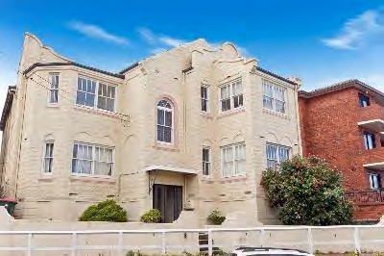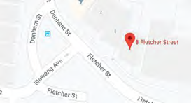
Image year |  | Image by | Google Maps | Image copyright holder

Image caption | 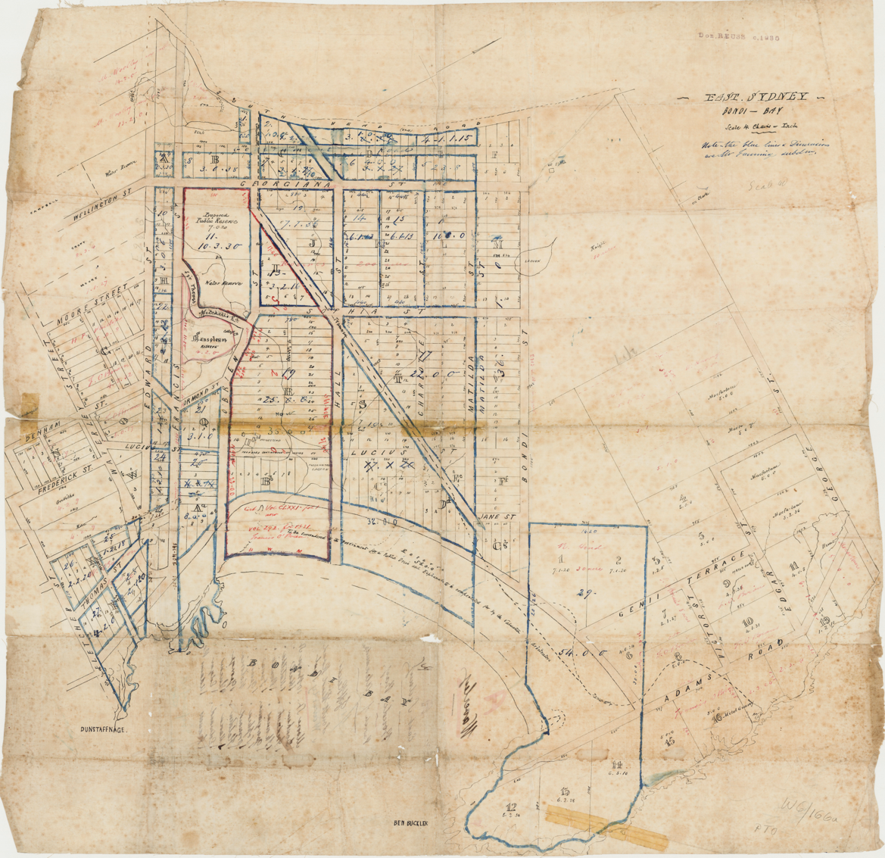
Image year | Undated | Image by | State Library of New South Wales | Image copyright holder

Image caption | 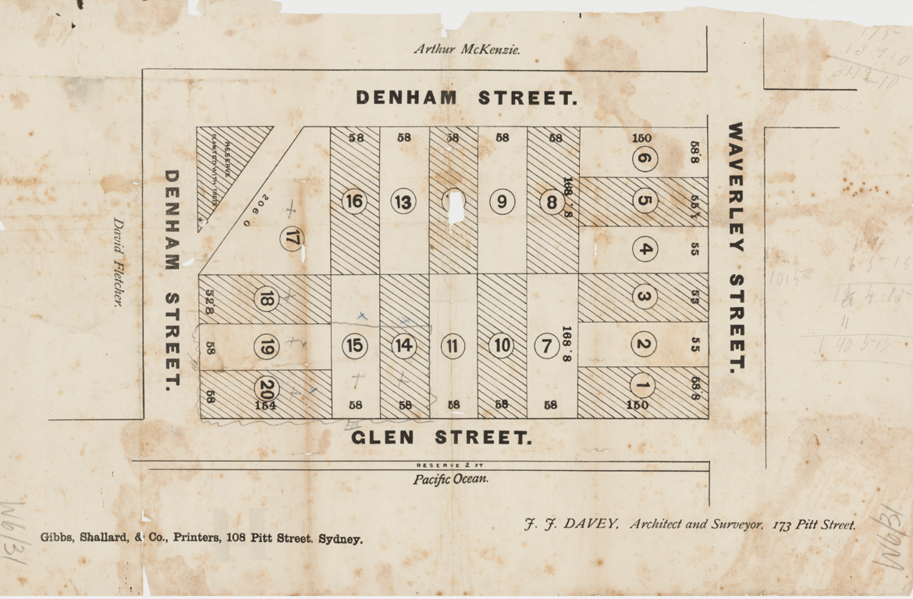
Image year | Undated | Image by | State Library of New South Wales | Image copyright holder

Image caption | 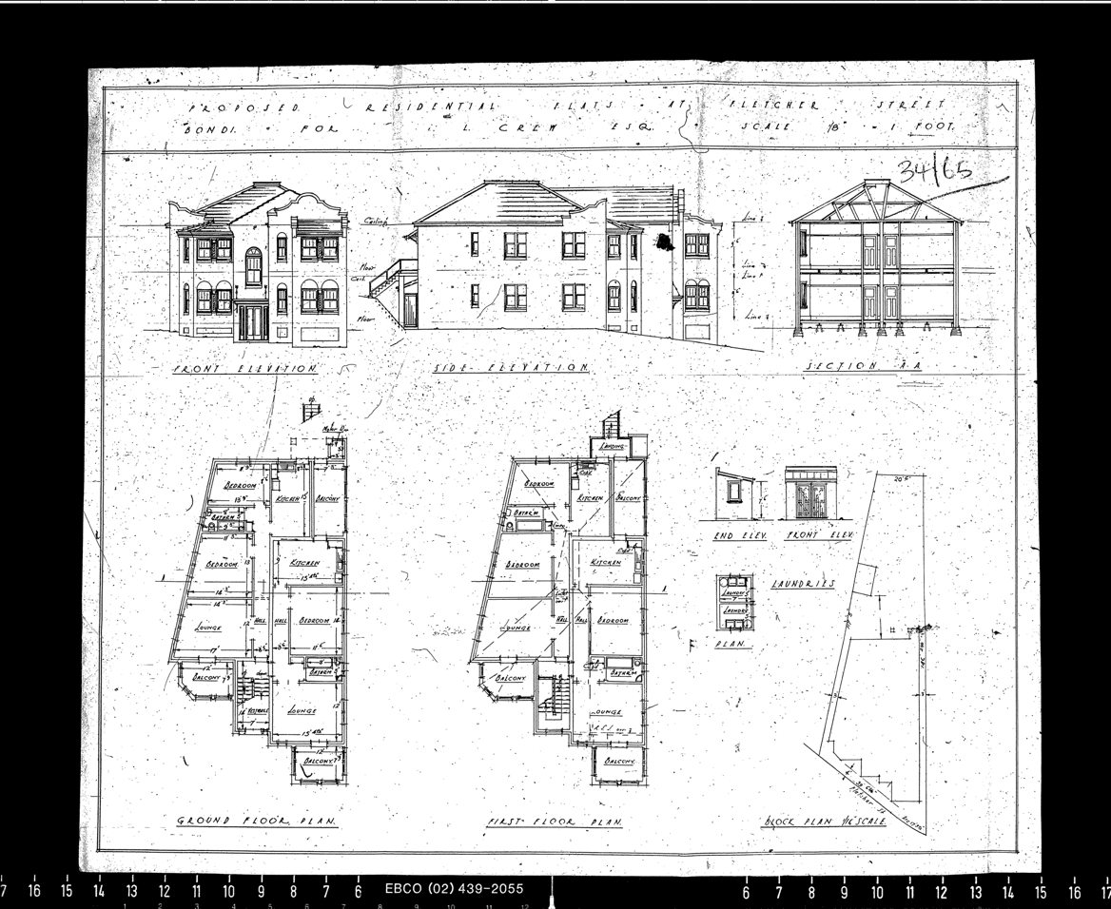
Image year | 1934 | Image by | Waverley Council | Image copyright holder

